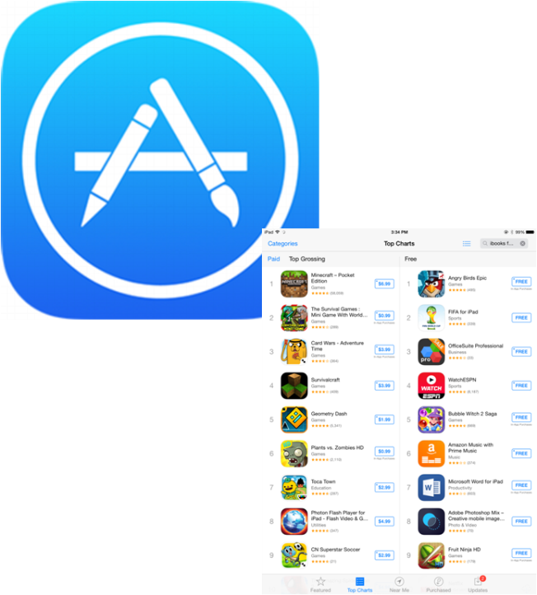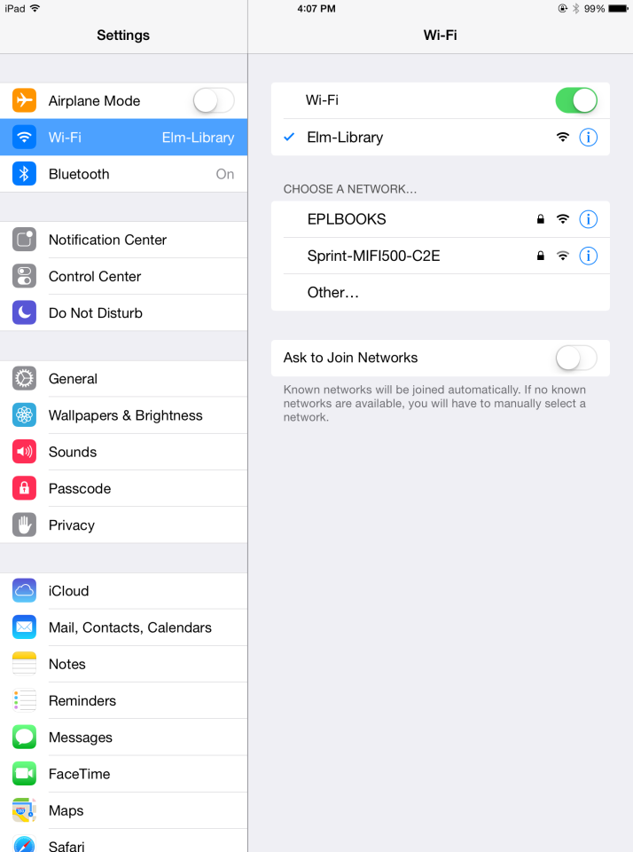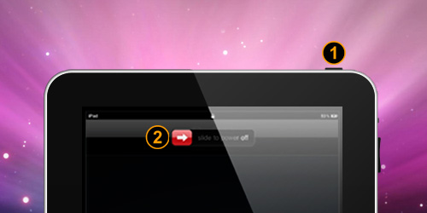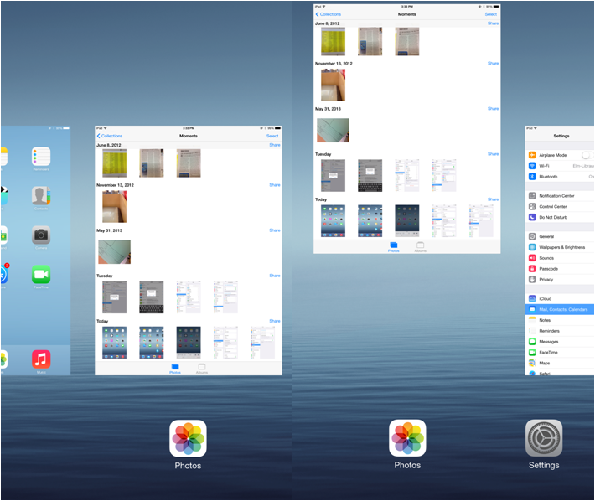

To setup up **wireless internet** connections (wifi) open up the settings menu and click on the network you wish to connect to

All **new apps** must be downloaded from the app store and require a login with your Apple id and a Credit Card

**To power down**, hold the sleep button (1) until the slide to power off appears on the home screen

**To close an app** tap the home button twice and slide the image of the app upwards until it disappears

iPad for Seniors